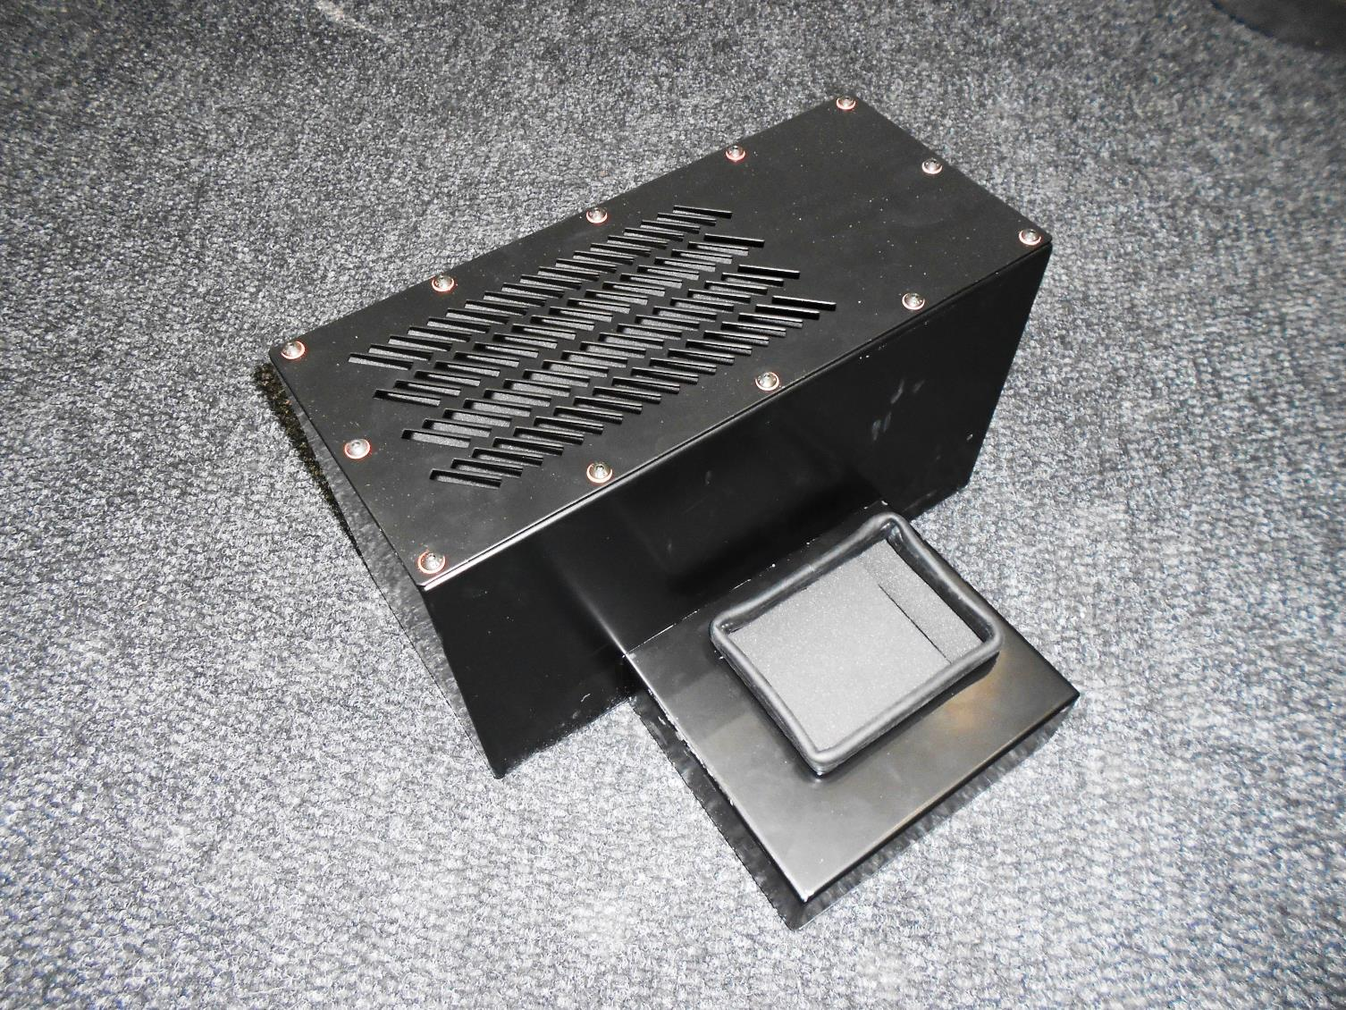
Print Pro Universal Silencer
Installation Guide

Overview
The Print Pro Universal Silencer is an optional extra that can be installed to the Print Pro Universal unit to reduce the noise given off during operation. It is quick and simple to install.
Installation
Place the silencer on the ground at the rear of the unit as shown in the photograph below.
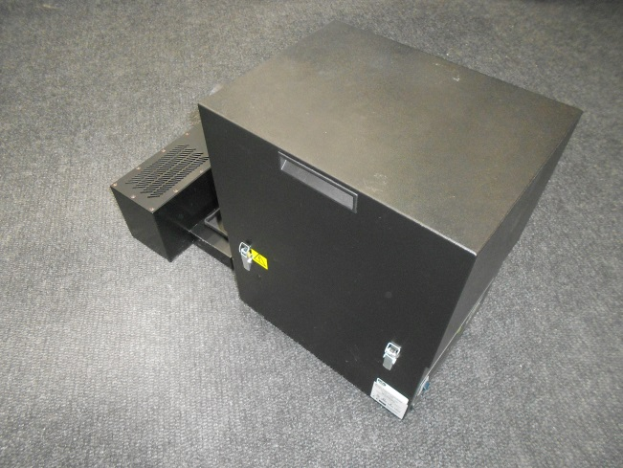

Lift the rear of the unit over the front compartment of the silencer as shown below making sure the rectangular cut out in the bottom of the unit sits inside the square flange on the silencer.
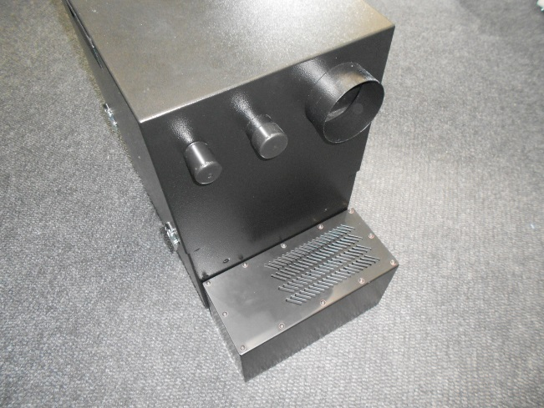
Spigot
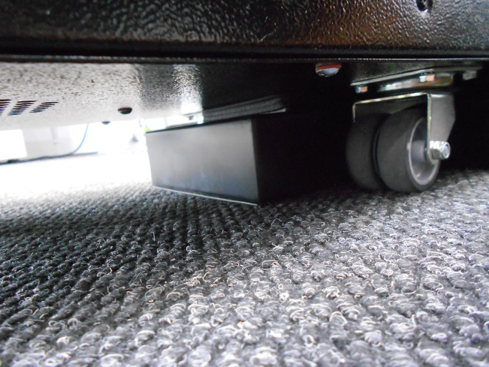
The silencer is now in place and ready for operation.

Caution
Due to the weight of the extractor suitable lifting equipment and/or lifting techniques should be used and with regard to appropriate safety precautions.
There are two types of silencer available:
- Vented
- Spigot (for the installation of ductwork)
The two different options are shown below.
Vented

